Visit the following Math class Java API link
http://docs.oracle.com/javase/6/docs/api/java/lang/Math.html
1. What do you notice about the methods in the math class?
- They are all static methods
- All of them return something
- There are a lot of overloaded methods
2. Look up the Java Subset http://www.collegeboard.com/student/testing/ap/compsci_a/java.html
List the five Math methods you are required to know for the AP exam: header of the methods
- Static int abs(int x)
- Static double abs(double x)
- Static double pow(double base, double exponent)
- Static double sqrt(double x)
- Static double random()
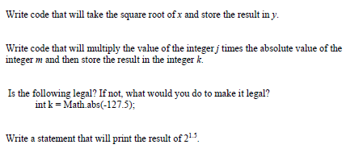
3. int y = Math.sqrt(x);
4. int k = Math.abs(m)*j;
5. Yes it is legal
6. System.out.println(Math.pow(2, 1.5));

7. Convert the equation into Java code (careful with the parenthesis)
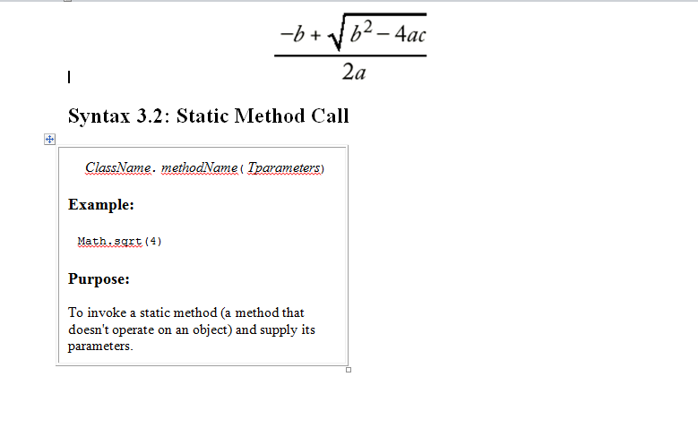
Int quadraticEquation = -(b) + Math.sqrt(Math.pow(b, 2) – (4*a*c))/(2*a);

8. Think about a math equation you may have tried to solve or can solve. Can your math equation/problem be solved using Math methods (Math Class). If so, which ones?
Int areaOfCircle = Math.PI * Math.pow(r, 2);
Math.pow(c, 2) = Math.pow(a, 2) + Math.pow(b, 2);
Int VolOfCylinder = Math.PI * Math.pow(r, 2) * h;

